**Opalis - RHPBIETL3 Access Issue**

**User Communication**

User communication not required.

**ISSUE#1 Failure Email – Couldn’t access RHPBIETL3 Server**

We got frequent failures regarding Opalis policies not accessing RHPBIETL3 server. Below are few opalis policies effected due to this failure.

OrderMethod

RBG GreenMileETL

Wrhse Pick Error Master etc.,

Below is the error screen shot details.

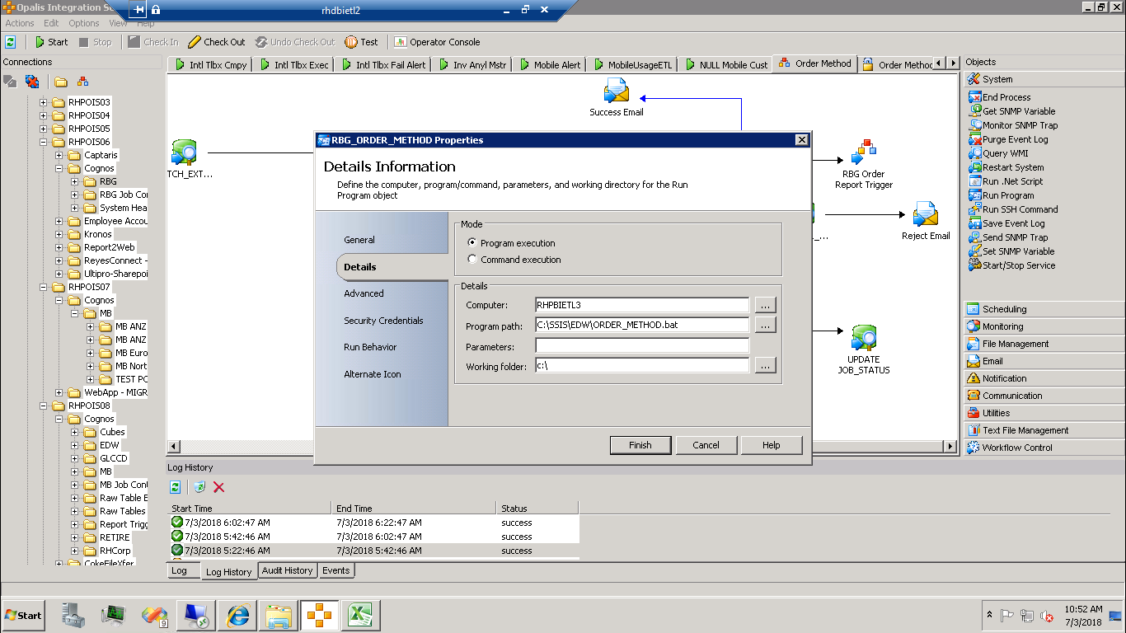

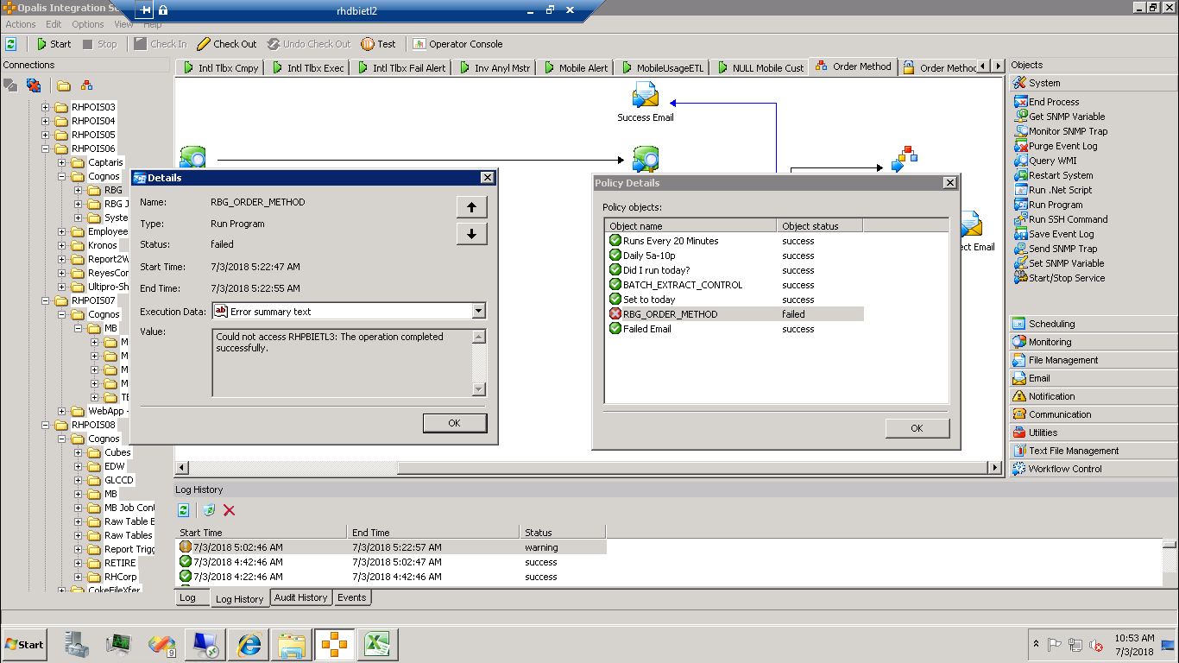

**Resolution:**

Below are steps to resolve the issue.

1) Stop the opalis policy which got failed due to RHPBIETL3 access issue.

2) Change the computer name to fully qualified name that is RHPBIETL3.REYESHOLDINGS.COM instead of RHPBIETL3.

3) Do check out and Check in.

4) Start the Opalis policy.

5) Restart the opalis policy through BI-Restart.